

Lab Report on Circle Drawing

**Course Code:** CSE 422

**Course Title:** Computer Graphics Lab

Submitted To: Hasin Rehana

Lecturer, Department of CSE

Daffodil International University

**Submitted By:** Nadim Mahmud Nion

ID: 181-15-1746

Section: PC-A

Department : CSE

**Date of Submission: 3/8/21**

Input:

#include <windows.h>

#include <GL/gl.h>

#include <GL/glut.h>

#include <math.h>

void display(void)

{

glClear (GL_COLOR_BUFFER_BIT);

glColor3f (1.0, 0.0, .0);

int i;

const int vertices=100;

const float angle= 2*3.1416/vertices;

float prevX=0 , prevY=0;

int r=1;

glBegin(GL_TRIANGLES);

for(i=0;i<=vertices;i++)

{

float newX= r*cos(angle*i);

float newY= r*sin(angle*i);

glVertex3f(0.0,0.0,0.0);

glVertex3f(prevX,prevY,0.0);

glVertex3f(newX,newY,0.0);

prevX= newX;

prevY= newY;

}

glEnd();

glFlush ();

}

void init (void)

{

glClearColor (0.0, 0.0, 0.0, 0.0); //select clearing (background) color

glMatrixMode(GL_PROJECTION);

glLoadIdentity();

glOrtho(-1.0, 1.0, -1.0, 1.0, -10.0, 10.0);

}

int main(int argc, char** argv)

{

glutInit(&argc, argv);

glutInitDisplayMode (GLUT_SINGLE | GLUT_RGB);

glutInitWindowSize (600, 600);

glutInitWindowPosition (100, 100);

glutCreateWindow ("hello");

init ();

glutDisplayFunc(display);

glutMainLoop();

return 0;

}

**Explanation:** There is circle object in openGL. So we can draw a circle by two method. One is Triangle and two is Polygon. In Triangle, we need three points. One point is fixed which is (0,0). We have to find other two points. For counting new point: we will use a formula:

For x-axis: radius*cos(angle)

For y-axis: radius*sin(angle)

This formula will apply for anti-clockwise.

For counting third point , we can initialize the value with zeros.

After moving to new triangle , new points value will move to previous point value and we will again count the new point value according the rules.

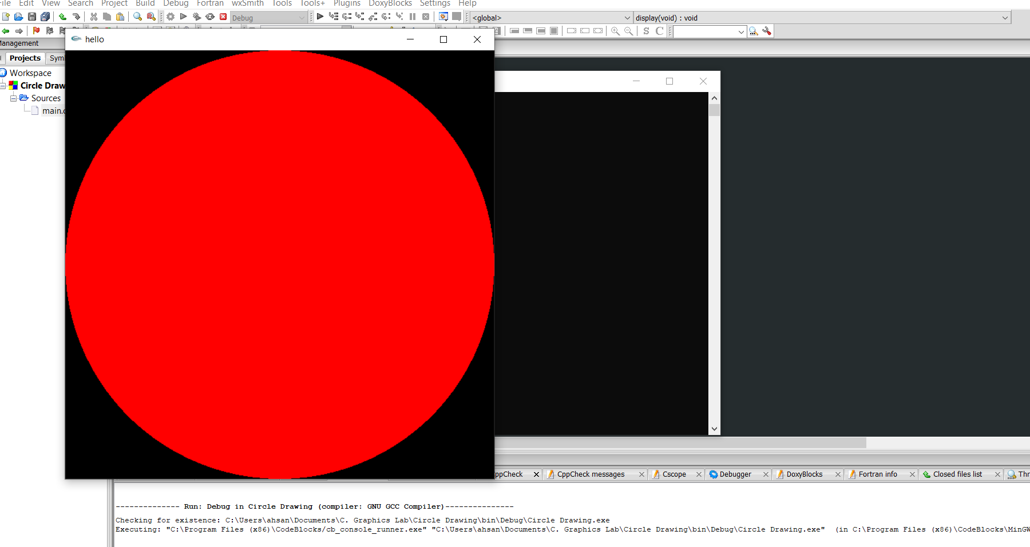**Output:**